Ai assisted coding Assignment-12.4
Name:E.Srivarsha
Batch-44
HTNO:2303a52343
Task 1: Bubble Sort for Ranking Exam Scores
Prompt Given to AI:
Implement Bubble Sort in Python to sort student scores. Add inline comments explaining comparisons, swaps and iteration passes. Identify early termination condition and provide time complexity analysis
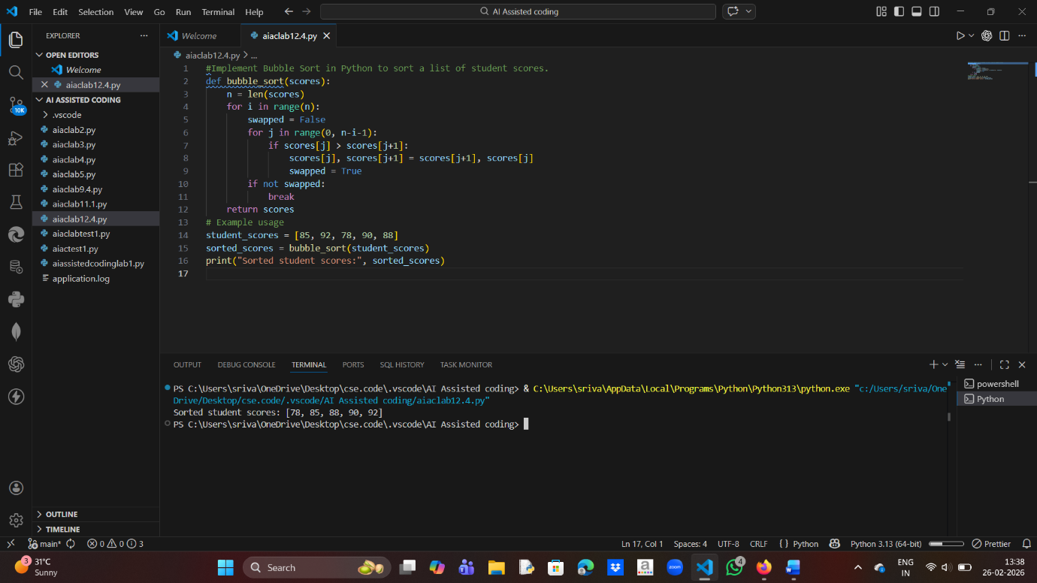
Time Complexity:
Best Case: O(n)
Average Case: O(n²)
Worst Case: O(n²)
Task 2: Improving Sorting for Nearly Sorted Attendance Records
Prompt Given to AI:
Suggest better sorting algorithm for nearly sorted data and implement it.
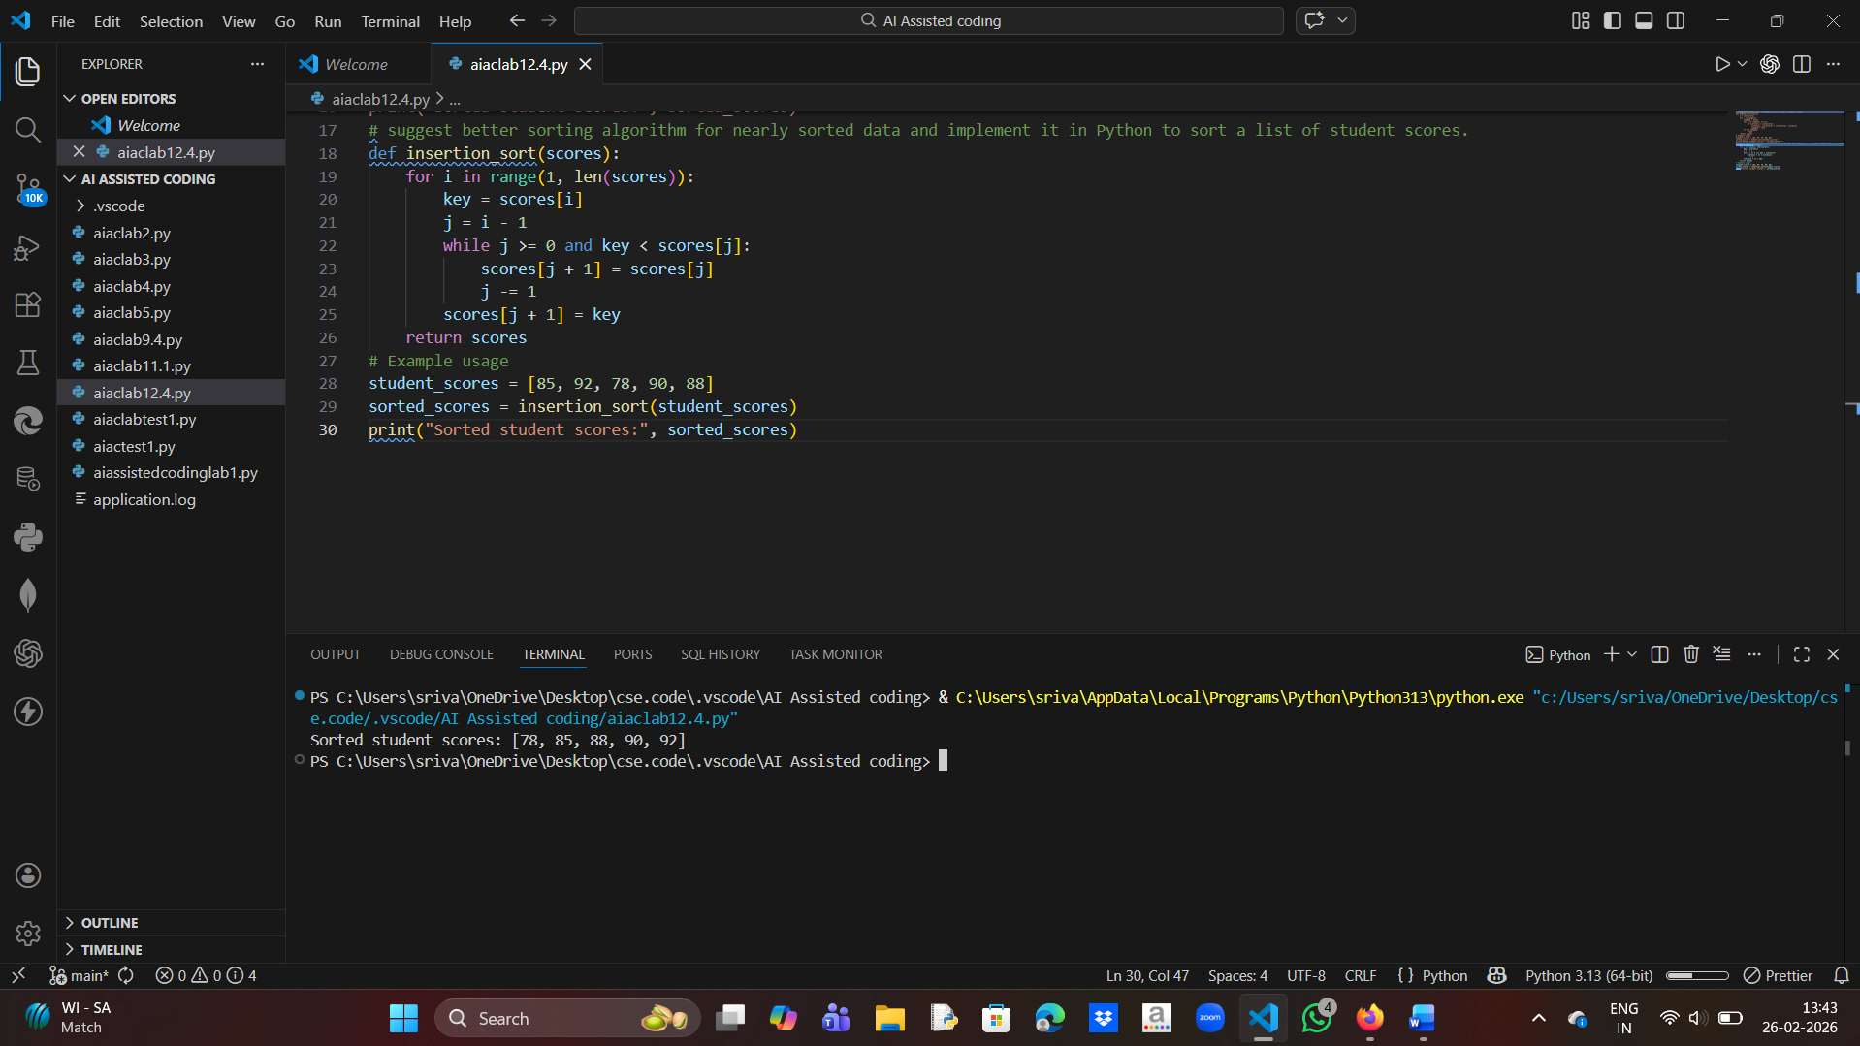
Explanation:
Insertion sort is efficient for nearly sorted data because it shifts only misplaced elements instead of performing repeated swaps like Bubble Sort.
Observation:
Insertion sort performs fewer operations when elements are already close to their correct positions.

Task 3: Searching Student Records in a Database
Prompt: Implement Linear Search and Binary Search in Python with docstrings. Explain when Binary Search is applicable and compare their time complexities.
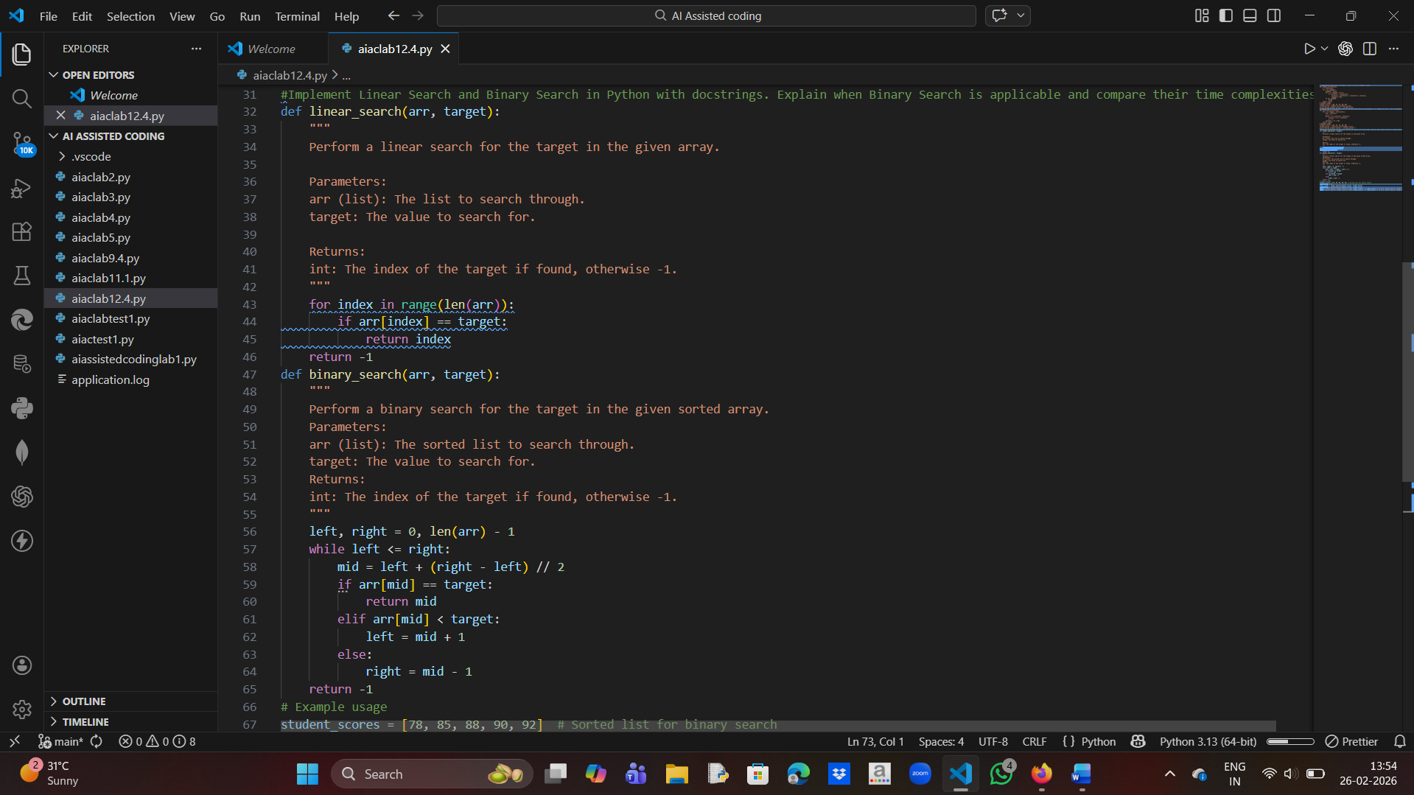
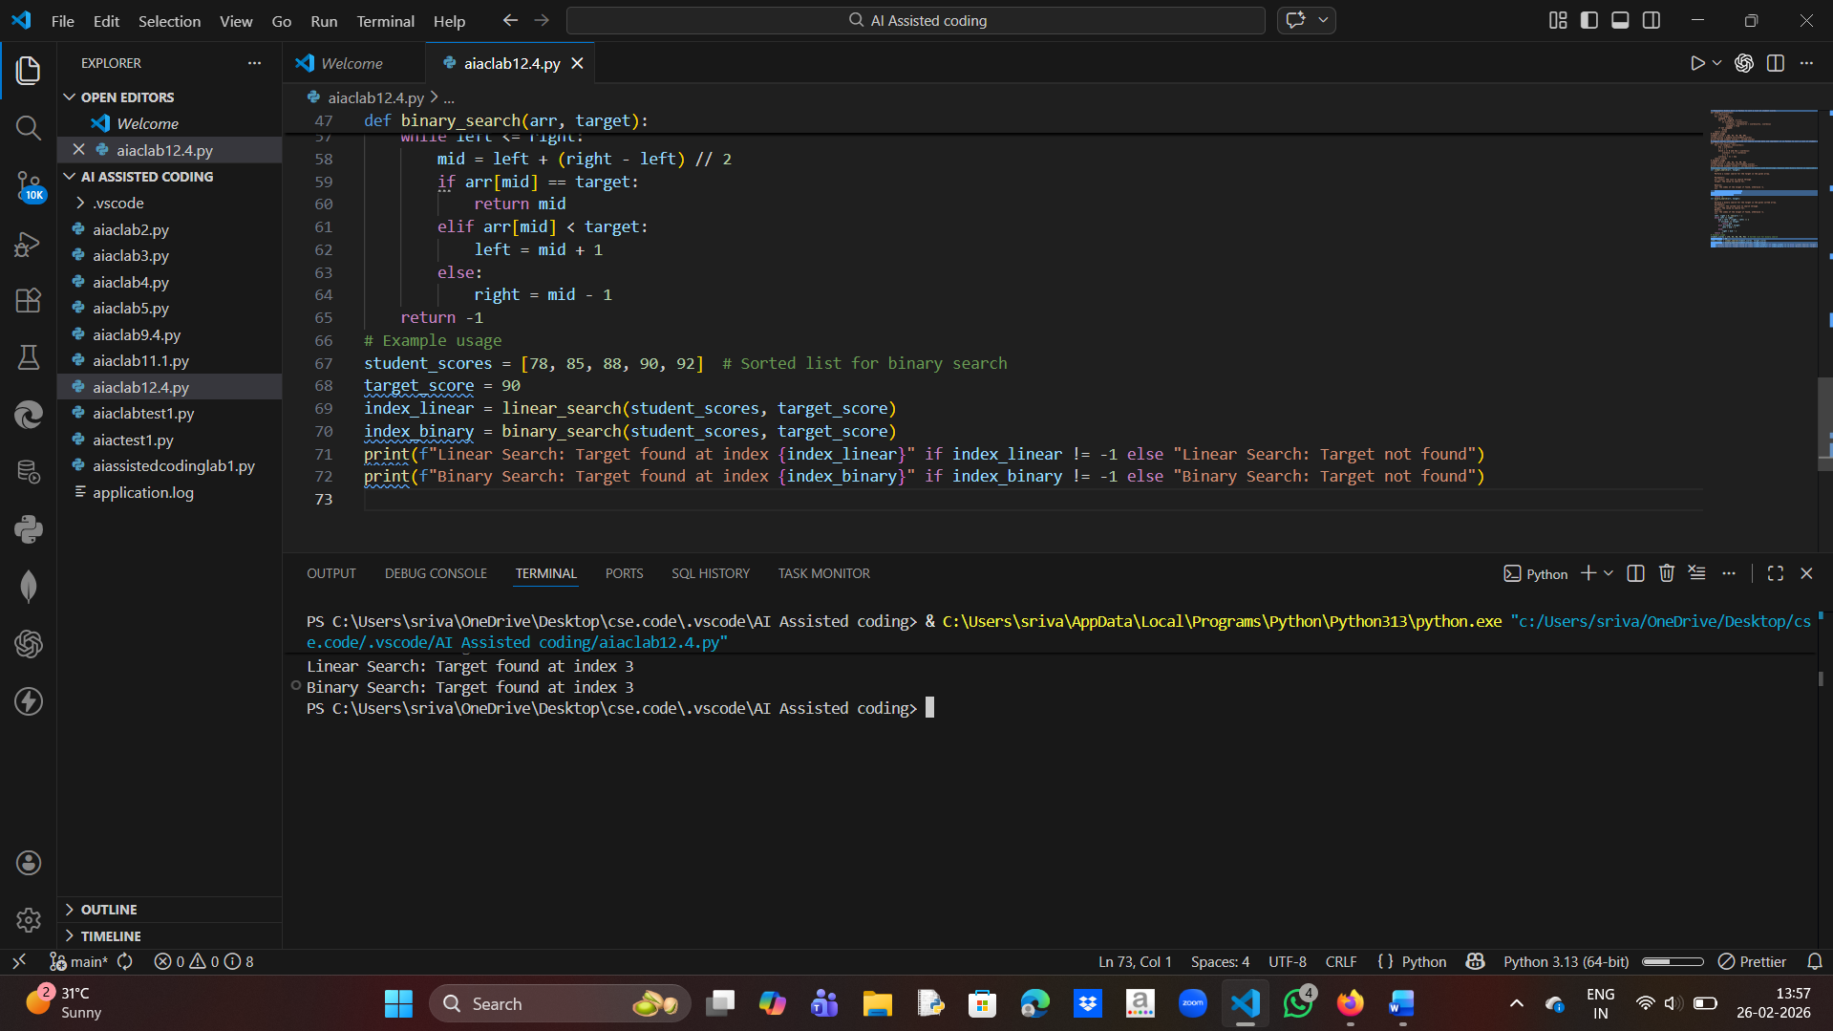
Explanation:
Binary Search is applicable only for sorted data.
Linear Search Complexity: O(n)
Binary Search Complexity: O(log n)
Task 4: Choosing Between Quick Sort and Merge Sort
Prompt: Complete Quick Sort and Merge Sort using recursion. Add docstrings, explain recursion, and compare their time complexities for different data cases.
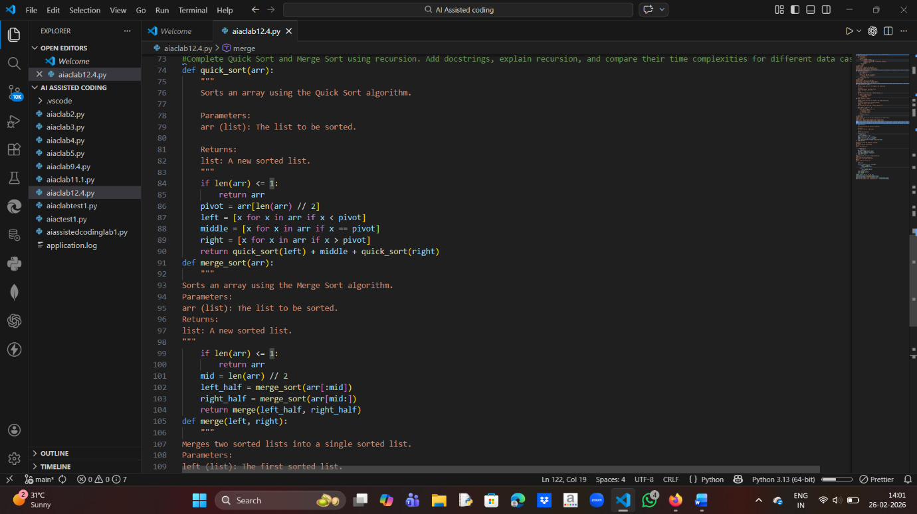
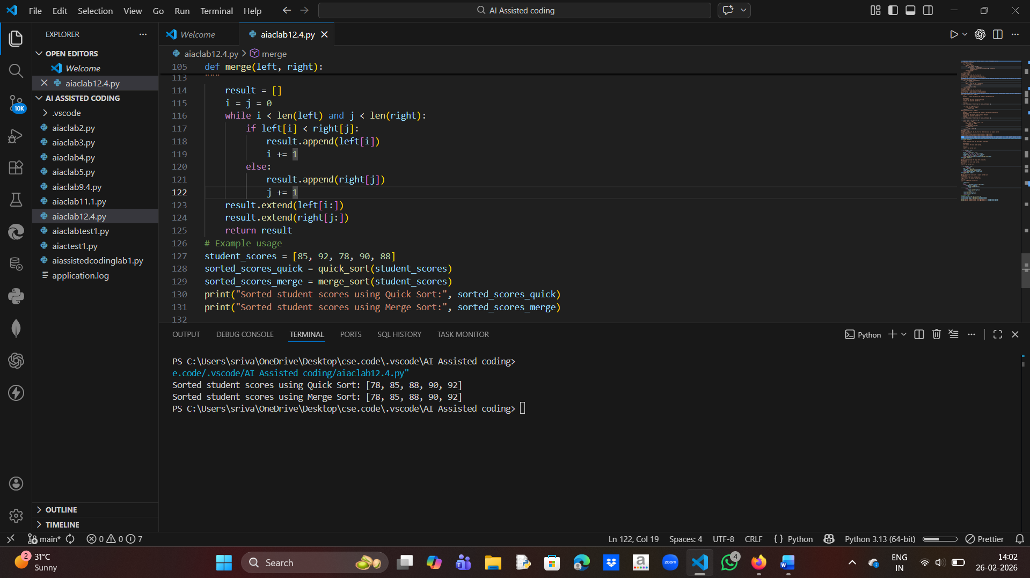
Complexity:
Quick Sort Best/Average: O(n log n)
Quick Sort Worst: O(n²)
Merge Sort: O(n log n)
Recursion Explanation:
Both algorithms divide the problem into smaller subproblems until single element remains and then combine results to get sorted list.
Task 5: Optimizing Duplicate Detection Algorithm
Prompt: Write a brute-force duplicate detection algorithm, analyze its complexity, then optimize it using a set and compare performance.
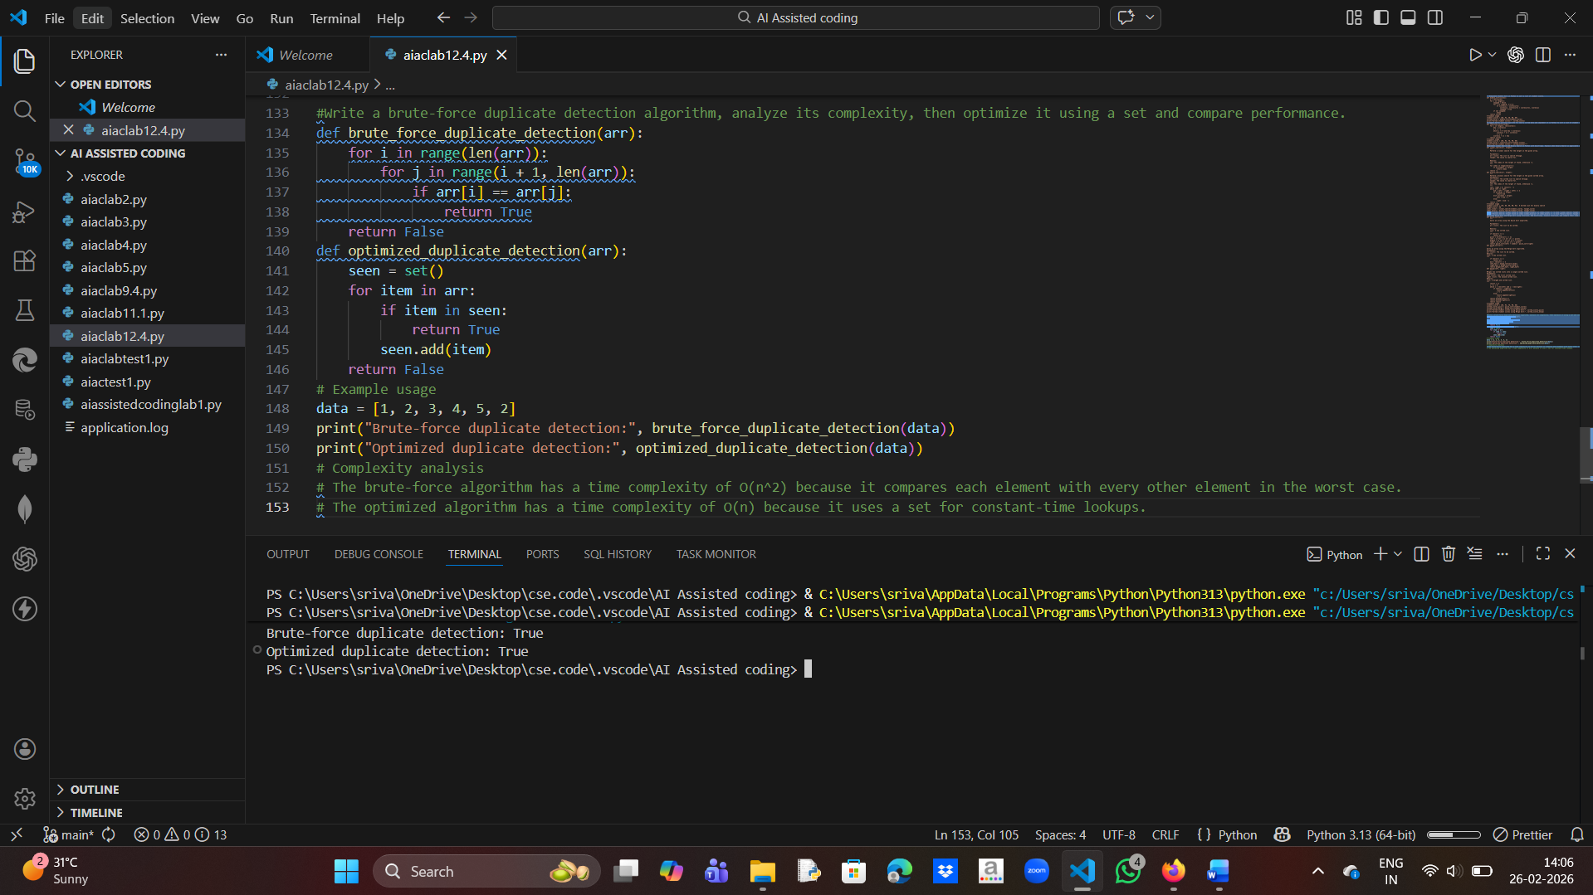
Complexity Comparison:
Brute Force: O(n²)
Optimized using Set: O(n)
Conceptual Observation:
Optimized approach reduces time complexity significantly for large datasets

